**Data Analysis Project Submission Report**

**1. Title Page:**

* **Project Title:** Sales Performance Analysis
* **Submitted By:**
* **Student Name:** Tarun Sam Emmanuel
* **Roll Number:** 2460651
* **College Email ID:** tarun.sam@btech.christuniversity.in
* **Course:** Fundamentals of Data Analysis
* **Instructor Name:** Dhiraj Alate
* **Institution:** Christ University
* **Date of Submission:** 18/08/2025

**2. Abstract:**

This project focuses on analysing a retail sales dataset to uncover key business insights and present them through an interactive Excel dashboard. The primary goal is to highlight both sales performance and customer behaviour by tracking essentials such as Total Sales, Profit, Average Order Value, and Customer Mix. Microsoft Excel was the tool used for data cleaning, transformation, and visualization, making use of Pivot Tables, Pivot Charts, Slicers, and Timelines to ensure clarity and interactivity. The final dashboard combines multiple perspectives including sales trends, category comparisons, regional contributions, and top customers to support better decision-making. The outcome is a user-friendly, dynamic reporting tool that enables stakeholders to quickly identify trends, evaluate customer segments, and optimize strategies for improved sales growth and efficiency.

**3. Objectives:**

* To clean and prepare the sales dataset by addressing missing values, standardizing fields, and creating calculated columns where necessary.
* To formulate and answer five key business questions that cover both sales performance and customer behaviour.
* To create a comprehensive, user-friendly Excel dashboard that visualizes essential KPIs such as Total Sales, Profit, Average Order Value, and Customer Mix.
* To use appropriate charts and graphs, including line, column, stacked, pie, and bar charts, to effectively communicate insights.
* To summarize the findings and highlight their business implications in a clear and concise manner, supporting data-driven decision-making.

**4. Scope of the Project:**

* Focused only on data cleaning, analysis, and visualization within Microsoft Excel.
* Prepared the provided retail sales dataset, ensuring accuracy and creating calculated fields when required.
* No use of programming languages (e.g., Python, R) or advanced statistical modelling.
* All work contained within a single Excel file.
* Analysis and findings are limited to the given dataset and based on identified trends and patterns.

**5. Tools & Technologies Used:**

|  |  |
| --- | --- |
| Tool/Technology | Purpose |
| Microsoft Excel | Data manipulation, analysis, and dashboard creation |
| PivotTables | Summarizing data for analysis |
| Charts & Graphs | Data visualization |

**6. Data Cleaning & Preparation:**

* The initial dataset contained multiple fields such as Order Number, Sales Amount, Product Category, Customer Type, Region, Sales Rep, Payment Method, and Date.
* Checked for and handled missing values where necessary to ensure accuracy.
* Removed any duplicates to maintain data consistency.
* Corrected data types (eg. ensuring dates were in Date format, sales and cost values as numeric).
* Created calculated fields, such as:
  + Sales Profit = Sales Amount – Unit Cost
  + Year, Month, and Month Name columns from Order Date for trend analysis.

**7. Dashboard Design Strategy:**

* The dashboard was designed to be *interactive* and *user-friendly*, allowing quick exploration of sales performance across different dimensions.
* A *timeline slicer* for Sale_Date enables filtering by year and month, making trend analysis easy.
* *Slicers* for Sales Channel, Customer Type, and Sales Rep provide dynamic filtering across all charts, improving interactivity.
* *Profit Trends of Products* (Clustered Column + Line): Shows Unit Price vs. Profit across categories (Clothing, Electronics, Food, Furniture), useful for identifying profitable categories.
* *Sales of Regions by Customer Type* (Stacked Bar Chart): Highlights how new vs. returning customers contribute within each region, offering customer segmentation insights.
* *Sales by Channel* (Pie Chart): Clearly communicates the proportion of Online vs. Retail sales.
* *Monthly Sales Trend* (Line Chart): Tracks overall sales performance over time, identifying seasonality and growth patterns.
* *Sales of Region by Products* (Clustered Column Chart): Compares product category performance across different regions, revealing regional preferences.
* The overall layout follows a top-to-bottom flow:
* Top: Filters and slicers for interactivity.
* Middle: Product-level profitability and customer mix.
* Bottom: Time-based and regional comparisons for deeper insights.

**8. Questions & Solutions:**

**Question 1:** Which product category generates the highest profit?  
**Analysis:** Used a clustered column + line chart comparing Unit Price and Profit across categories (Clothing, Electronics, Food, Furniture).  
**Solution:** Clothing shows the highest profit, closely followed by Furniture, while Food contributes the least profit.

**Question 2:** How do Online and Retail sales channels compare?  
**Analysis:** Used a pie chart to display the share of sales by channel (Online vs. Retail).  
**Solution:** Online and Retail sales are almost evenly distributed, with Online slightly leading, indicating balanced channel performance.

**Question 3:** How do new vs. returning customers contribute across regions?  
**Analysis:** Created a stacked bar chart showing sales by Customer Type across each region.  
**Solution:** Returning customers contribute a larger share of sales in most regions, especially in the East and West, suggesting strong customer loyalty.

**Question 4:** What are the sales trends over time?  
**Analysis:** Used a monthly sales line chart with a timeline slicer for filtering by year and month.  
**Solution:** Sales show fluctuations across months, with noticeable peaks mid-year (around June–August), highlighting seasonal sales patterns.

**Question 5:** Which region performs best across product categories?  
**Analysis:** Created a clustered column chart comparing category sales across regions (East, North, South, West).  
**Solution:** The East and West regions show consistently higher sales across categories, while the South lags behind, highlighting areas for growth focus.

**9. Challenges Faced & Solutions:**

|  |  |
| --- | --- |
| Challenge | Solution |
| Challenge 1: Deciding which KPIs (Profit, Sales, Trends) to display without overcrowding. | Solution: Selected the most relevant KPIs and arranged them in a clear top–middle–bottom layout. |
| Challenge 2: Choosing the right chart type. | Solution: Used line charts for trends, bar charts for comparisons, and a pie chart for proportions. |
| Challenge 3: Managing interactivity with multiple slicers. | Solution: Added slicers for Channel, Customer Type, Sales Rep, and Date, ensuring all visuals update dynamically. |

**10. Outcome:**

* The analysis revealed key insights such as Clothing and Furniture being the most profitable categories, returning customers contributing significantly to sales, and seasonal sales peaks mid-year.
* The interactive dashboard proved useful in visualizing trends, comparing categories and regions, and filtering results by channel, customer type, and sales rep, making it a practical decision-making tool.
* During the project, skills in data cleaning, PivotTables, chart selection, and dashboard design were enhanced, along with experience in presenting business insights clearly through Excel.

**11. Screenshots of Final Output:**

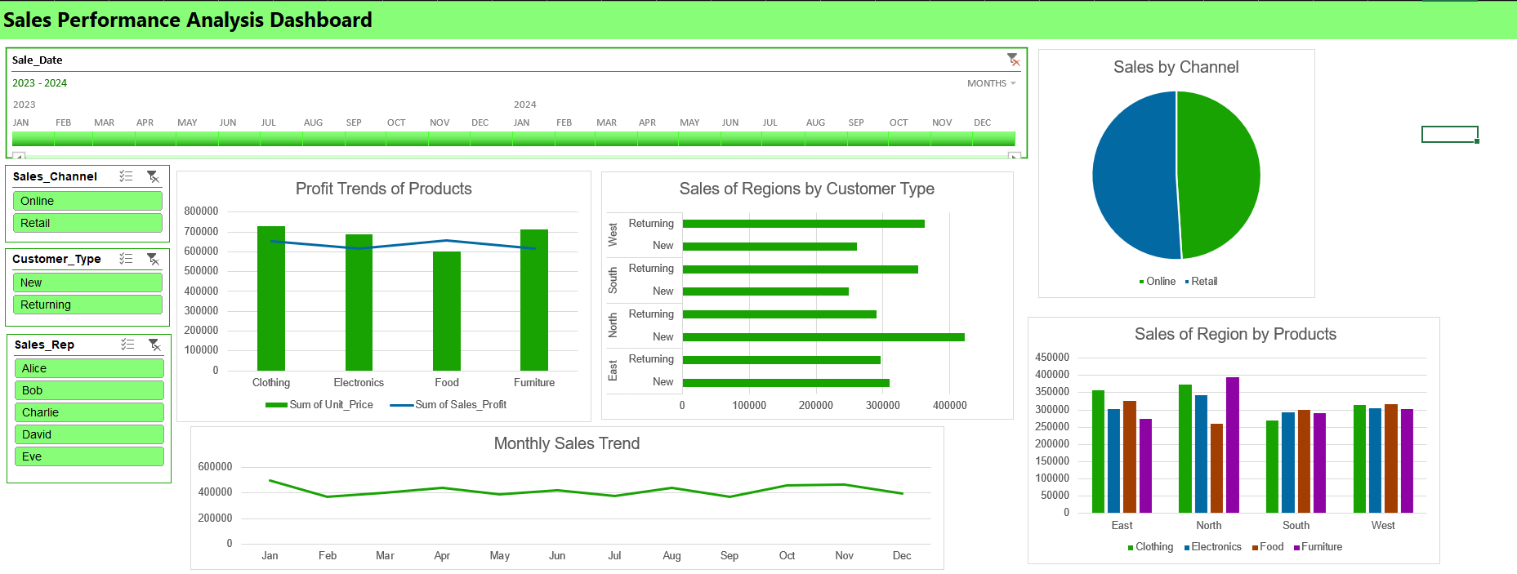

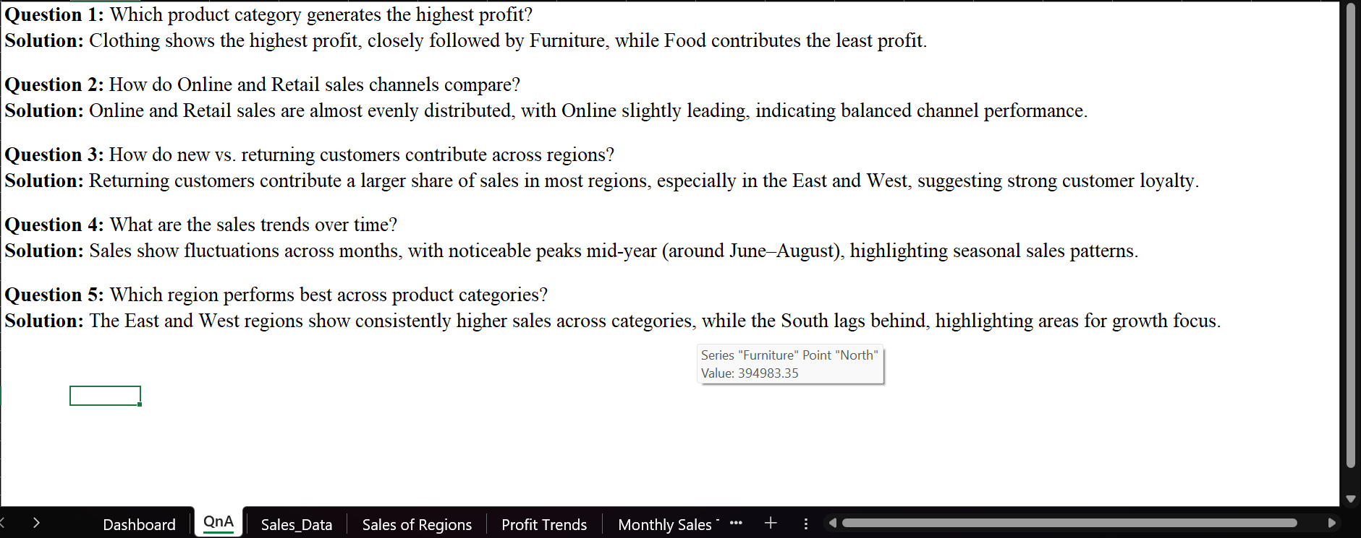

**12. Conclusion:**

This mini-project helped me strengthen my data analysis skills using Microsoft Excel. I gained practical experience in data cleaning, transformation, and visualization, ensuring that raw data was turned into meaningful insights. Designing the interactive dashboard improved my ability to select the right charts and KPIs to communicate findings effectively. Most importantly, working with a real-world dataset enhanced my understanding of how data-driven insights can support business problem-solving and informed decision-making.

**13. References:**

https://www.kaggle.com/datasets/vinothkannaece/sales-dataset